**6. Application and evaluation of simulations**

**6.1. Architectural design**

As we have studied in previous lessons that acoustics is the study of sound and its propagation, whereas, auralization makes sound pressure audible at the ears of the listener by replay of the signals by an appropriate audio reproduction equipment. There are many applications of room acoustic simulations in the area of architectural designs. In virtual environments acoustics play an important role. For example, acoustic simulations can significantly increase the virtual presence of the users. Spatial sounds, through auralization, allow users to locate objects and perceive their own movement. The challenge in designing virtual auditory environments is the consideration of the entire signal transmission path from the source to the eardrum. One of the most important applications of acoustics, in addition to the research and reduction of noise (urban planning and sound design) is the effort to design and simulate the architectural spaces to meet the specific requirements of the design procedures.

Architectural acoustics deals with sound in buildings and is usually subdivided into room acoustics and building acoustics. In classical room acoustics, optimal conditions for music perception and speech communication are the main goals. However, room acoustics also deals with other spaces, such as foyers, workplaces, oﬃces and classrooms, where optimum acoustic conditions include aspects of noise control. When it comes to sound transmitted between rooms in a building the airborne sound insulation of the connecting structural elements of the rooms must be taken into account along with the aspects of structure-borne excitation from water installation, heating, ventilation or air condition systems in order to determine the overall acoustic performance of the building. As we discussed in previous lessons, the acoustic performance can be predicted with various theoretical models such as analytical or numerical wave models, geometrical acoustics (GA) and statistical energy analysis (SEA). In this lesson we will learn about some of the many applications of the room acoustics simulation methods. With the rapid development of computers and, hence, a signiﬁcant increase in processing power, more sophisticated acoustical simulation methods are established and applied in the sound ﬁeld analysis of rooms and buildings. For this purpose the very first requirement is an architectural design software which is used to construct rooms and building to acoustically simulate them. Some examples of these commercially available architectural software are: Rhino 3D, Revit Architecture, SketchUp, V-Ray, AutoCAD, Maya, ArchiCAD and Grasshopper etc. After having architectural design of any environment, the room acoustical simulation are carried out using State-of-the-art commercial software for room acoustical simulation, such as, CATT-acoustic, ODEON, EASE, and CadnaR etc. In the following paragraph, we will discuss few of the software tool among them to evaluate their usage and practicality. The ﬁeld of application has broadened vastly as not only music and the quality of concert halls, or other performance spaces, are to be evaluated but also the perception of general sound and noise.

**Room Acoustics**

Figure 1 shows an example of room acoustical simulation of an opera house by RAVEN. Figure 1a shown a CAD Model which is used as input architectural design, whereas Figure 1b illustrates the visualization of early reflections originating from source and end up at receiver end at some position. The final impulse responses are given in Figure 1c.

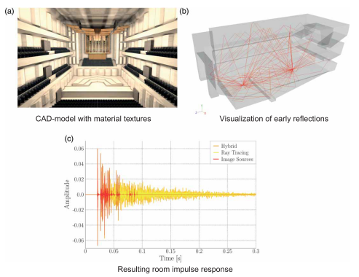

**Figure 1:** An example of room acoustic simulations and visualization of opera house

These simulations help up to understand how sound propagates inside the closed spaces and how a certain architectural design responds to the room acoustical properties based on which one can improve the acoustics of any space by re-designing it. In practice is also used to virtually create existing rooms and to simulate the e.g. speech indelibility in the whole room, to see where improvements are most useful. An Example is shown in Figure 2. These software solutions provide the opportunity for room acoustics parameters computation in a very sophisticated manners based on available ISO standards and guidelines. Similar other auralization software like ODEON, CandnaR, Catt-Acoustic software,….

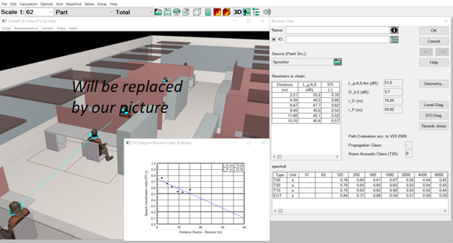

**Figure 2:** SketchUp (later on will be Replaced with RAVEN)

**6.1.2. Building Acoustics**

**In building acoustics, there are also software available which are used for prediction of sound insulation characteristics of building elements from where the performance of buildings under noise protection is possible to evaluate. Especially airborne and impact sound transmission are calculated between adjacent rooms, and airborne sound transmission from the exterior sound sources as well. These softwares are based on measurement databases and ISO: 12354 for prediction of airborne sound transmission with offline auralization feature.**

Figure 3 shows an example of the usage of building acoustics auralization in Virtual reality using Unity 3D and VBA. It is used to auralize different Building environments and can be used for conducting Listening experiments in Virtual reality.

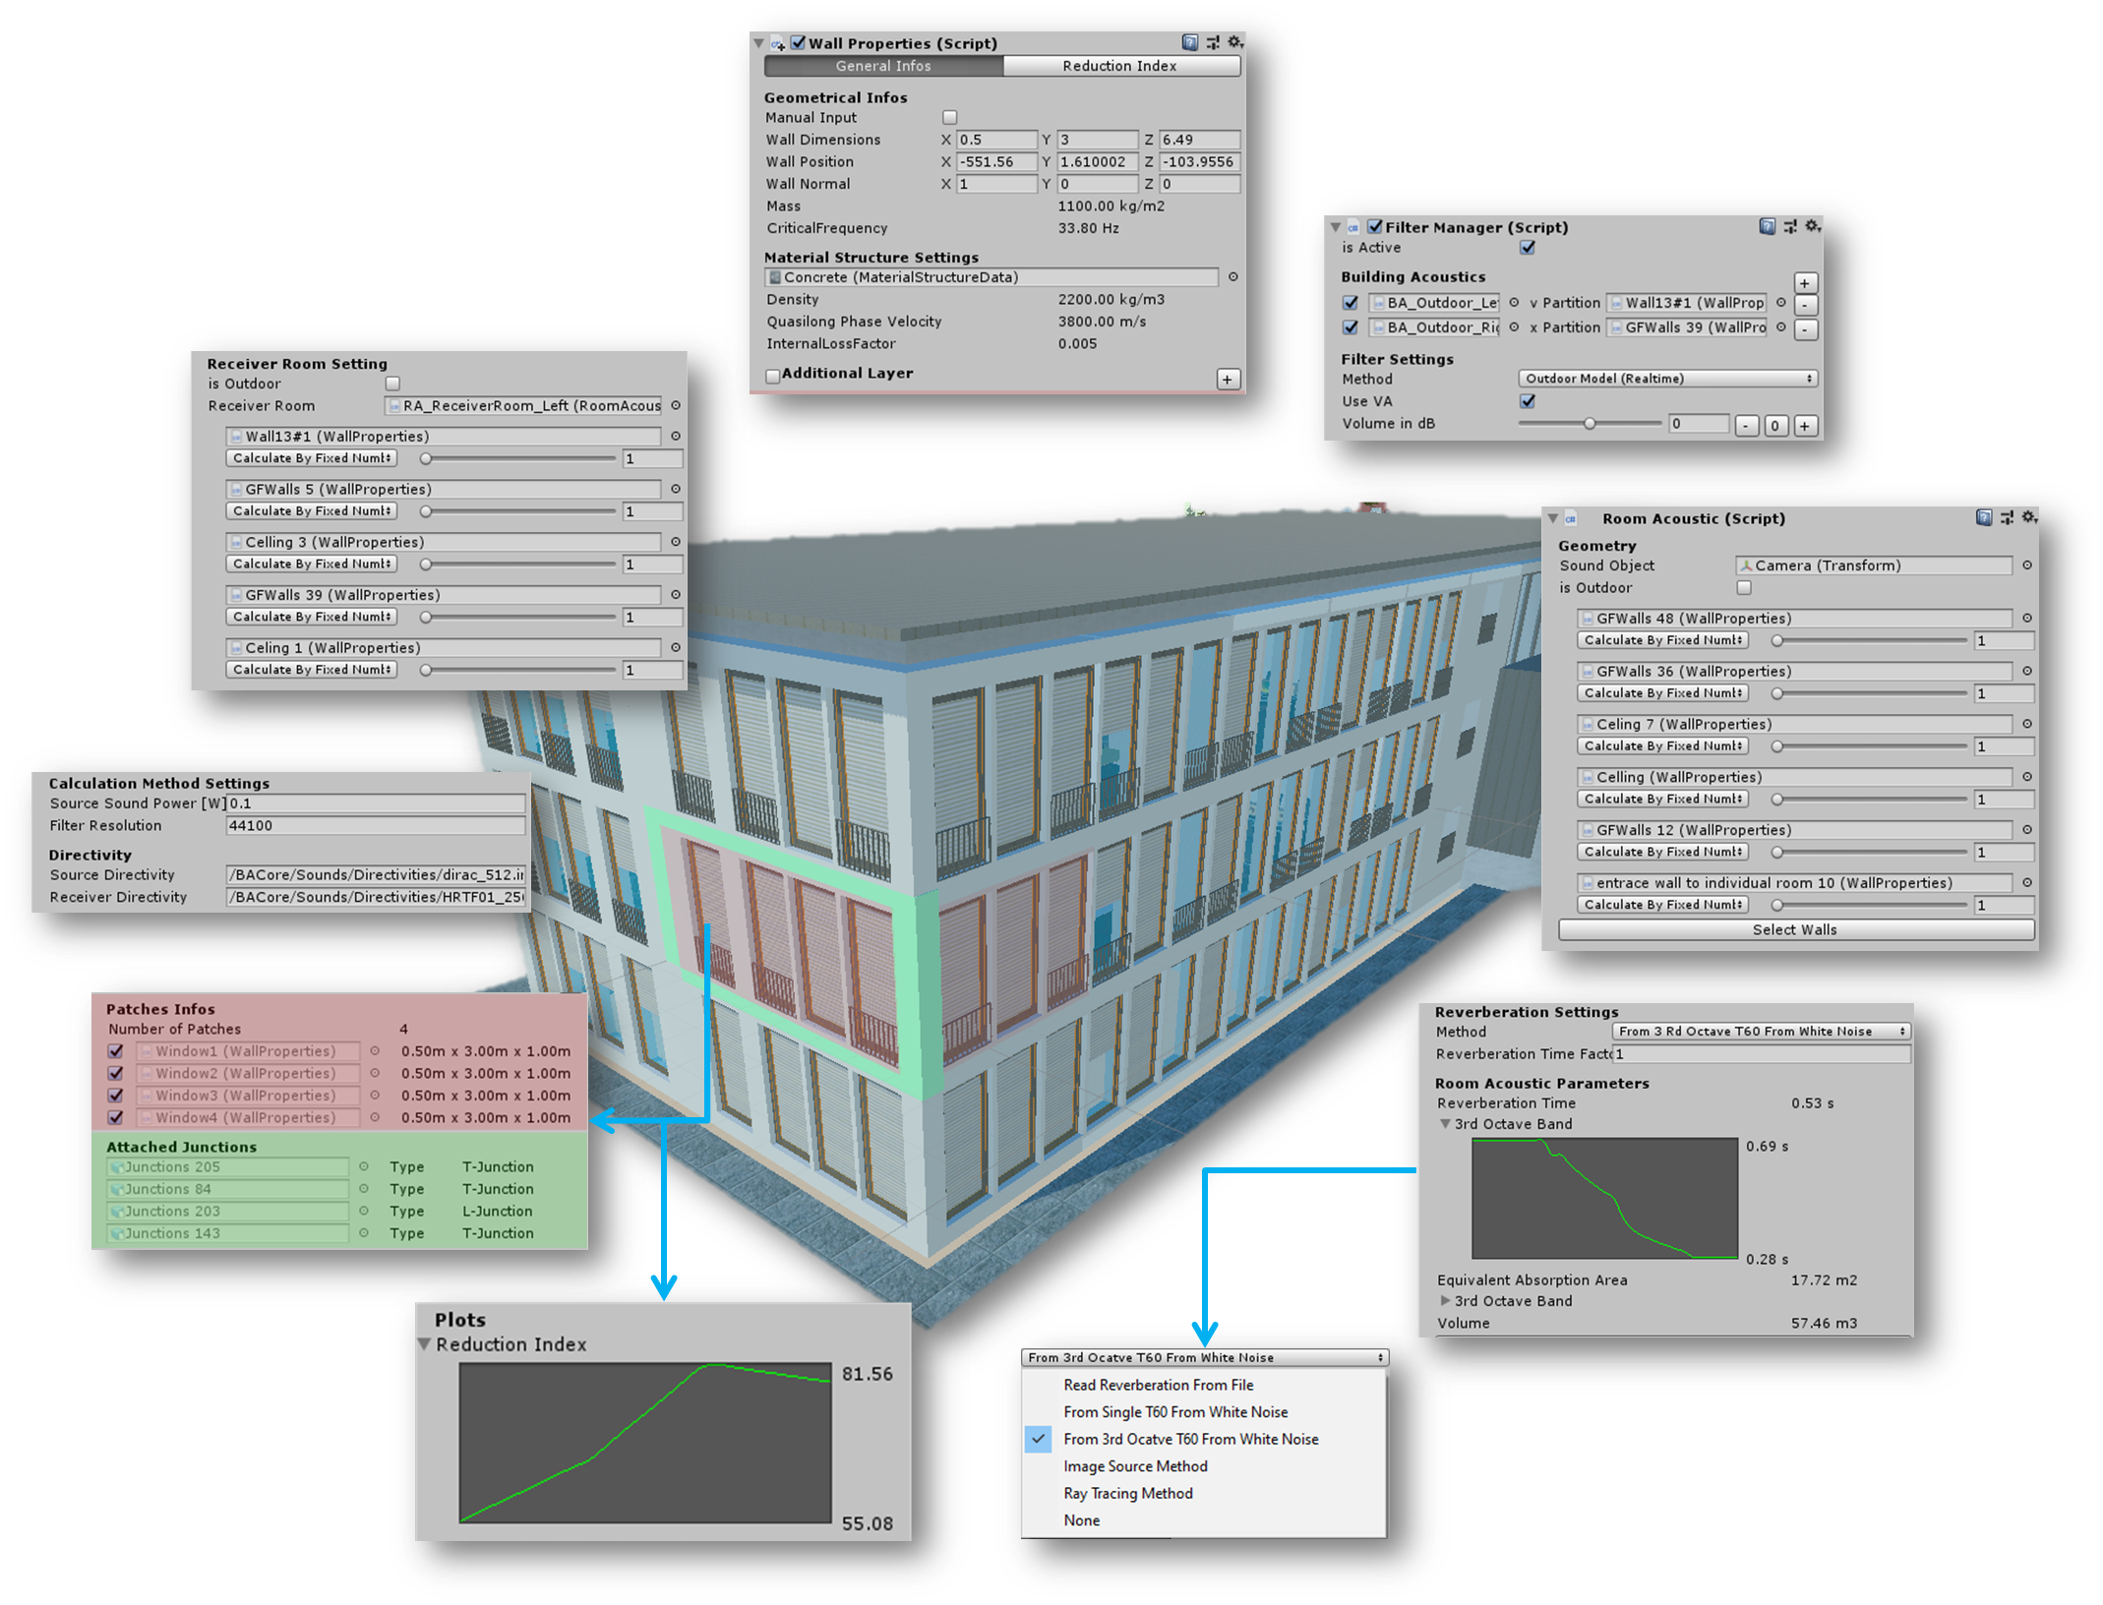

**Figure 3:** Building Acoustic Auralisation (here put something

**6.2. Urban Planning and Noise Mapping**

The applications of acoustic simulation are not only restricted to the indoor spaces, but also extended toward outdoor environments, such as urban design and planning and simulations and auralization of urban noise sources. Many commercial software are developed for calculation, assessment and presentation of outdoor noise. For example, CadnaA, SOUNDPlan, …

These software solutions are for the calculation and assessment, prediction and presentation of environmental noise exposure of different environments, such as an industrial plant, commercial centres including a parking lot, road or railway scheme or even of entire towns and urbanized areas. One common use case is the acoustic simulations of a whole area where the sound pressure level or other quantities can be visualized on a map. This is very useful for urban environment architects and city planner. An example is given in Figure 6 from a Noise map from Mithra Sound software from France.

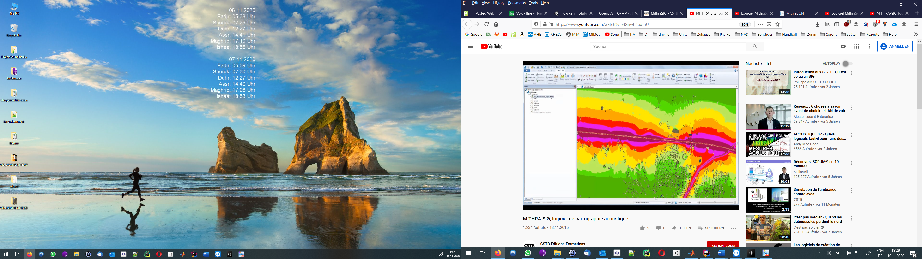

**Figure 6:** Get some example from France (example from their YouTube video)

Another use case in urban noise control in the urban environment is, for example, the virtual measurements of different international or national standards. In this way the noise emissions can be estimated before building something. For example, an airport, to estimate the noise pollution beforehand makes the planning easier.

**6.3. Research**

In previous lessons we have seen the usage of listening experiments in psychoacoustic, but with auralization and visualisation a lot of more research is possible. All kind of psychological experiments under different noise conditions are possible, e.g. Cognitive performance tests, emotions, sound scape tests, health effect on daily working life. In this lesson we will discuss some examples of listening experiment in audio-virtual reality.

The present study adopted a human-centred approach to explore the potential of audio-visual VR to evaluate indoor noise protection by building characteristics, including room acoustics and building acoustics. Different background speech conditions, convolved with acoustics filters of closed spaces, for example office rooms, open plan offices, are possible to be presented in virtual acoustical environment and the effects on cognitive performances and subjective ratings can be measured. For example, a study on cognitive performance of human under building acoustic condition was conducted by Schlittmeier et al. (2008) and later on extended by Imran et. al. (2019).To find the effect patterns on cognitive performance under different Sound conditions a audio virtual scene was as seen in Figure7 . This example promises new options for research on noise effects by the use of virtual built environments which are of high plausibility and unlimited variability. The potential of using a human-centred approach integrating audio-visual VR to evaluate indoor noise protection by building characteristics was exemplarily demonstrated in this study. The sound effect pattern on cognitive performances - in terms of verbal short-term memory - and subjective ratings were the same as those measured in a real and audio-only laboratory setting.

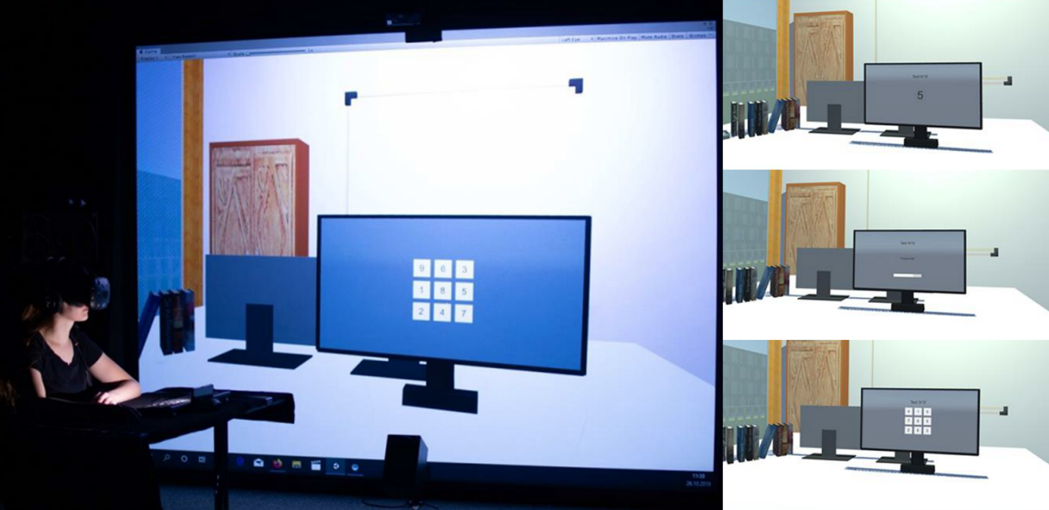

Another example of room acoustical simulation and applications in listening experiments is the study of series of listening tests by Schröder (2011), which were carried out for ﬁve room scenarios (living room, classroom, lecture room, concert hall and metro station) for doing performance tests on the room acoustics simulations. These models signiﬁcantly diﬀer in size and reverberation time and, thus, comprise ﬁve very diﬀerent sound characteristics. Appropriate aural stimuli were identiﬁed. For example, only low-order ISs (specular reﬂections), higher order ISs and RT methods were taken into account separately.

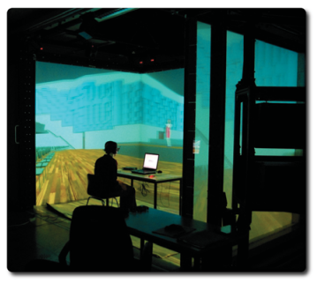

Figure 12.1: Subject performing listening tests in a virtual environment.

**6.4 Uncertainties of simulations**

**6.5 Validation (Comparison to measurements)**

**6.6 Perceptual evaluation**